Current Reads

Session 2 Take Home activity

**Note:**

1. Create a folder, "session2-takehome" in the Sandbox shared with us.
2. Create a file, "index.html" inside the session2-takehome" folder. Add HTML for this exercise to this "session2-takehome/index.html" file

A lot of people add the links of the books which they are reading on their personal blog. A user needs to have a page built to show their current reads. The screenshots are attached as reference. Replicate a similar page according to the given checklist.

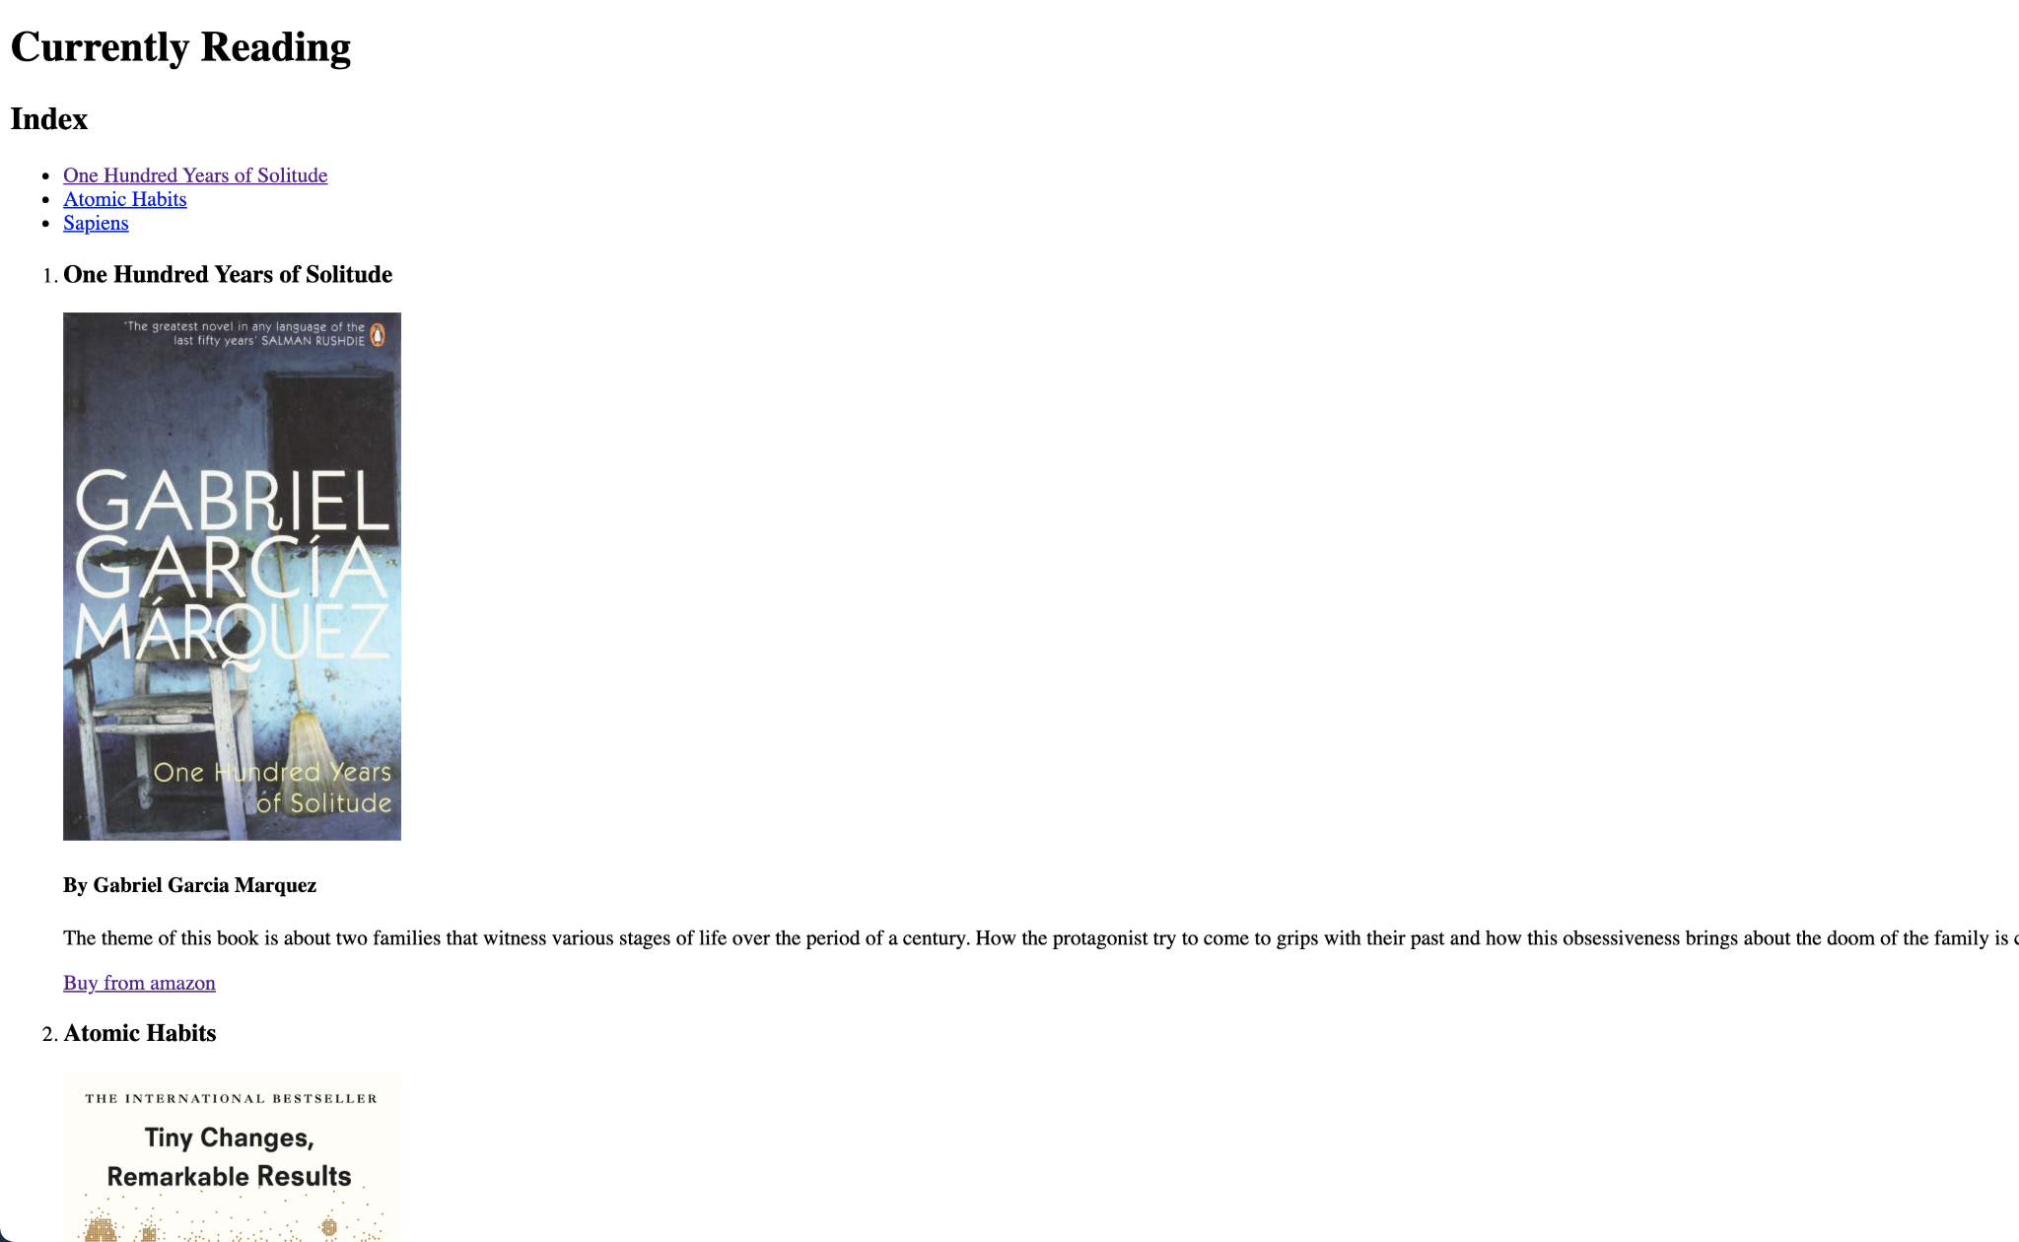

## **Checklist**

* The webpage should have a title - “Current Reads”
* The page body should have a main heading - "Currently Reading"
* It should have a subheading saying - "Index"
* Under the "Index" heading there should be a list of books the user is currently reading (see appendix for the content)
* Each item in the list should link to the section of that book.
* Each book in Appendix should have their own section consisting of the following
  + One heading with the book name
  + Image of the book cover. Recommended Size 256 x 400 (256px wide, 400px tall)
  + Author name as an even smaller heading.
  + A summary paragraph of the book
  + A link to it's Amazon page
* A back to top link
* A small heading saying - "Website developed by"
* Your name and your Twitter/GitHub handle with it's link

## **Appendix**

The appendix contains the information about the books which the user is currently reading.

### **1. One Hundred Years of Solitude**

By Gabriel Garcia Marquez

Summary - The theme of this book is about two families that witness various stages of life over the period of a century. How the protagonist try to come to grips with their past and how this obsessiveness brings about the doom of the family is captured in the novel.

Buy from amazon link -<https://www.amazon.in/Hundred-Years-Solitude-International-Writers/dp/0140157514>

Image Link -<https://images-na.ssl-images-amazon.com/images/I/91hJ+hgZm4L.jpg>

### **2. Atomic Habits**

By James Clear

World-renowned habits expert James Clear has discovered a simpler system for transforming your life. He knows that lasting change comes from the compound effect of hundreds of small decisions - doing two push-ups a day, waking up five minutes early, or holding a single short phone call. He calls them atomic habits.

Buy from amazon link -<https://www.amazon.in/Atomic-Habits-James-Clear/dp/1847941834>

Image Link -<https://images-na.ssl-images-amazon.com/images/I/91bYsX41DVL.jpg>

### **3. Sapiens: A Brief History of Humankind**

By Yuval Noah Harari

Summary - Earth is 4.5 billion years old. In just a fraction of that time, one species among countless others has conquered it: us. In this bold and provocative book, Yuval Noah Harari explores who we are, how we got here and where we're going.

Buy from amazon link -<https://www.amazon.in/Sapiens-Humankind-Yuval-Noah-Harari/dp/0099590085>

Image Link -<https://images-na.ssl-images-amazon.com/images/I/713jIoMO3UL.jpg>

## Reference Images

The page should look something like this.

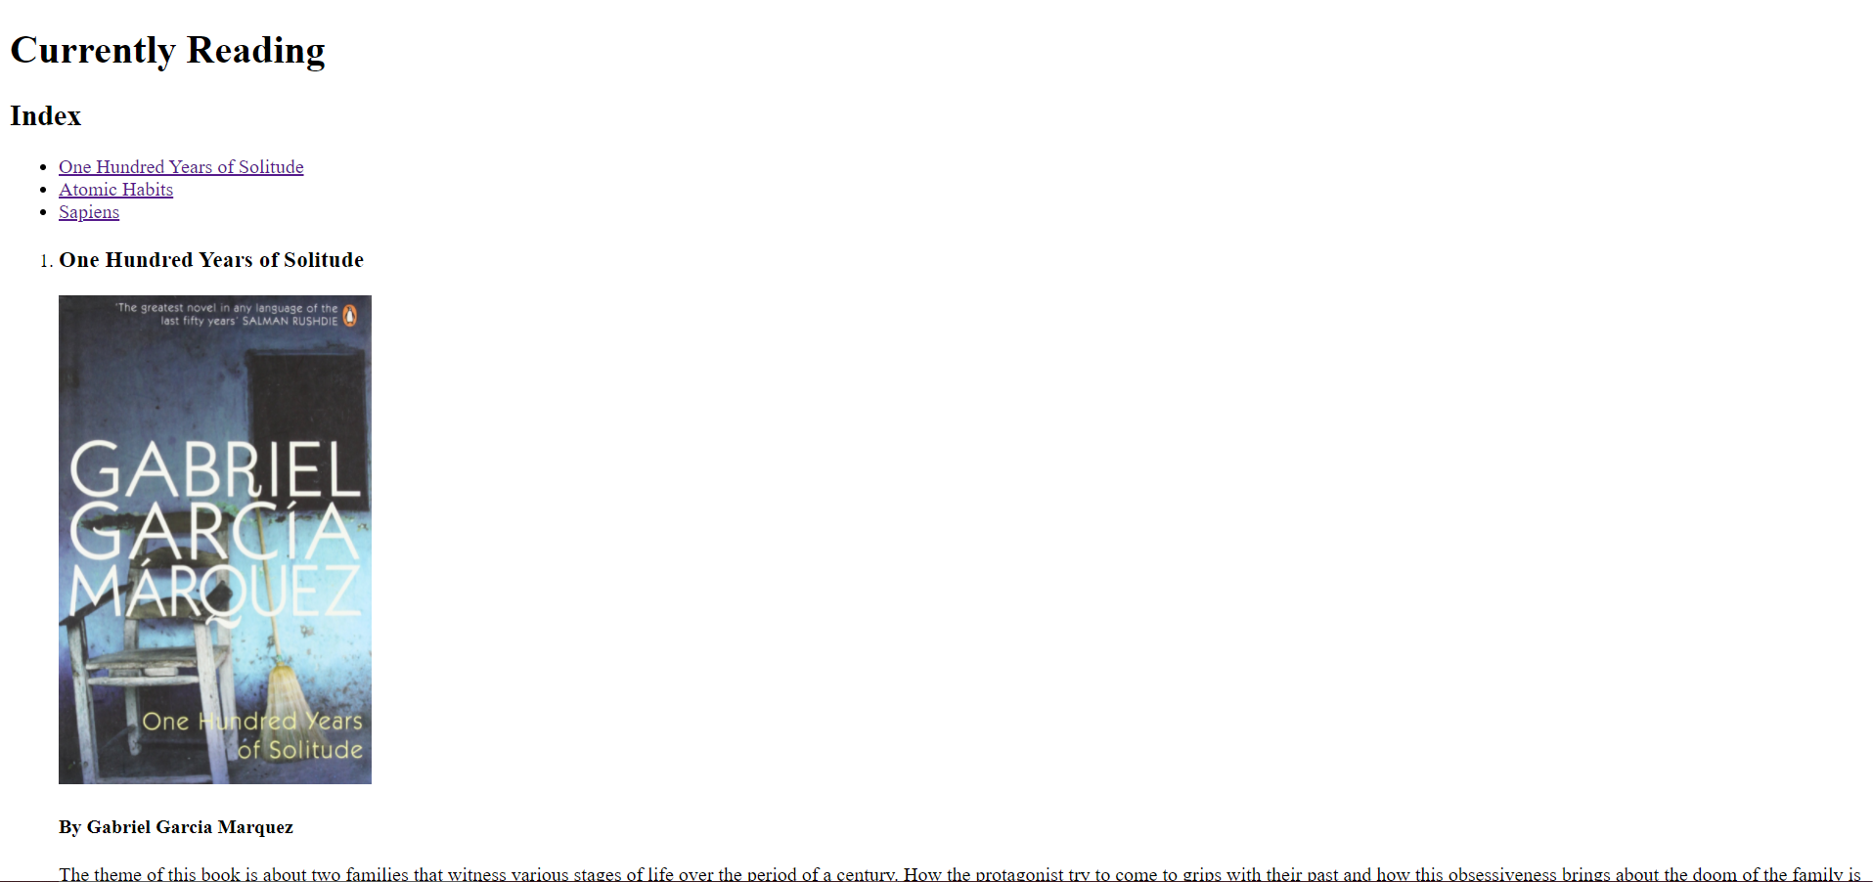

Each book section should look something like this

